**LICENSE PLATE RECOGNITION**

**Mohan Ram R (20BCE1742)**

**ABSTRACT**

License plate recognition is a system that detects and recognises licence plates in digital photos or video footage. Inception ResNetV2 and YOLOv5 models, which can precisely identify and recognise licence plates in real-time, are used in the proposed study for licence plate recognition. These efforts are crucial for improving the effectiveness and precision of licence plate recognition systems, which have numerous uses in traffic control, parking management, and law enforcement. The results obtained from the YOLOv5 model was better than the results produced by Inception ResNetV2.

**Keywords:** Inceptions ResNetV2, YOLOv5, Tesseract OCR

**INTRODUCTION**

License Plate Recognition (LPR) technology has become an essential tool for law enforcement, parking management, and tolling systems to automate the identification of vehicles and improve safety and security. In this project, we have utilized state-of-the-art computer vision techniques to develop an efficient and effective LPR system.

The system relies on the YOLOv5 and inceptionresnetv2 models, which are popular deep learning architectures used for object detection and recognition. The models were trained on a custom dataset, which includes a diverse range of license plate images, to accurately detect license plates from a variety of angles, lighting conditions, and backgrounds.

Once the license plates are detected, the project utilizes OpenCV, an open-source computer vision library, to extract the license plate region from the image. This region is then passed to Pytesseract, an optical character recognition (OCR) tool, to perform text recognition and obtain the license plate number.

The developed LPR system has demonstrated high accuracy and speed in detecting and recognizing license plates from images. The system's accuracy and robustness make it suitable for deployment in various scenarios, including parking lots, highways, and tolling systems.

**LITERATURE SURVEY**

**1) "License plate recognition using CNN with a sub-net for character segmentation"**

(IEEE Access, 2018) The paper proposes a method for license plate recognition using a convolutional neural network (CNN) with a sub-net for character segmentation. Advantage: The proposed method achieves high accuracy in license plate recognition and character segmentation using a single neural network. Disadvantage: The method requires a large amount of training data to achieve high accuracy. Transfer Learning techniques and data augmentation can be used to reduce the amount of training data required for high accuracy.

**2) "Automatic license plate recognition system using improved hybrid feature selection and a novel machine learning algorithm"**

(Expert Systems with Applications, 2018) Advantage: The proposed method achieves high accuracy in license plate recognition using a novel machine learning algorithm and improved feature selection. Disadvantage: The method is computationally expensive due to the use of multiple feature extraction techniques. Simplifying the feature extraction process, such as by using more efficient feature selection techniques or reducing the number of feature extraction methods used.

**3) "License plate recognition based on deep learning and multiple-feature fusion"**

(Journal of Visual Communication and Image Representation, 2019) Advantage: The proposed method achieves high accuracy in license plate recognition by combining multiple feature extraction techniques and deep learning. Disadvantage: The method may not perform well under variable lighting conditions. Exploring the use of illumination normalization techniques or data augmentation methods that simulate different lighting conditions.

**4) "A hybrid method for license plate recognition using morphology and deep learning"**

(Journal of Ambient Intelligence and Humanized Computing, 2021) Advantage: The proposed method achieves high accuracy in license plate recognition by combining morphology-based segmentation and deep learning-based character recognition. Disadvantage: The method may not perform well when the license plates are partially occluded or have non-standard font styles. Exploring more advanced morphological operations or using context-aware techniques.

**5) "Robust license plate detection and recognition using deep learning and genetic algorithm optimization"**

(Neurocomputing, 2021) Advantage: The proposed method achieves high accuracy in license plate detection and recognition using a combination of deep learning and genetic algorithm optimization. Disadvantage: The method may not perform well under low-resolution images or lowquality video footage. Enhancing the image quality, such as by using super-resolution techniques or denoising methods.

**PROPOSED WORK**

Inception ResNetV2 and YOLOv5 are two prominent models that have been investigated in the proposed work for license plate recognition. This research involved training both models using a dataset of images and their corresponding bounding box values stored in an XML file, which was done using the Imglabel tool.

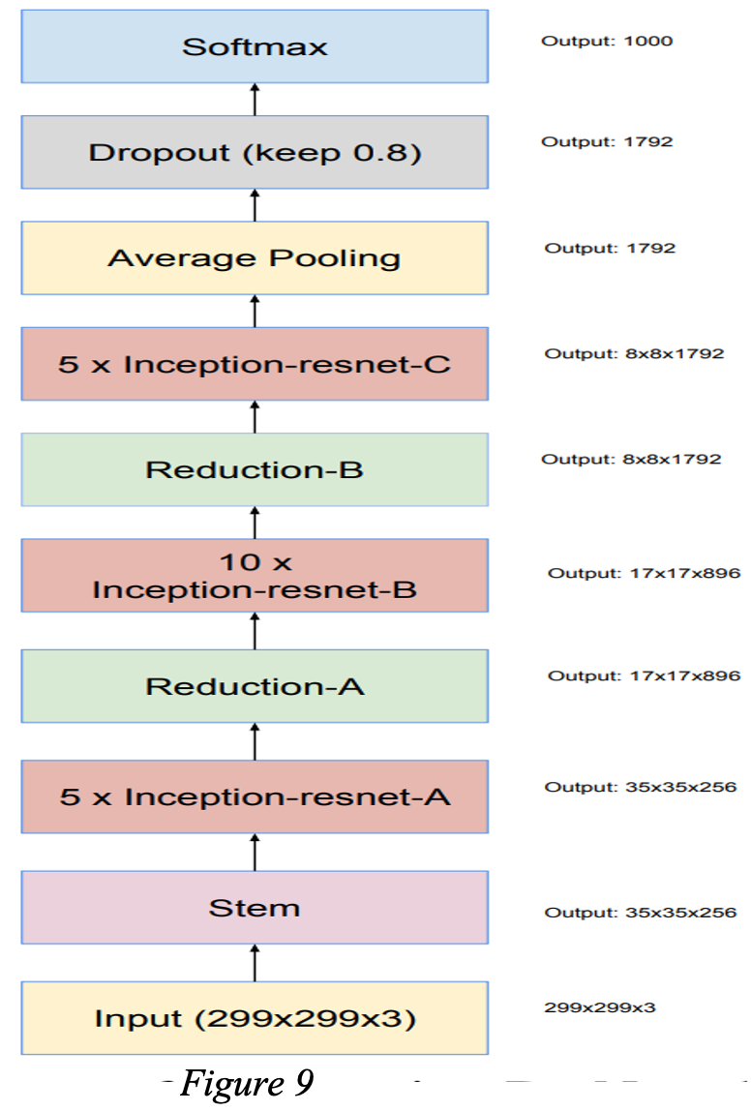

The Inception ResNetV2 model was run for 150 epochs and utilized pre-trained weights from the ImageNet dataset to build its architecture. The model also included several dense layers with various activation functions to output the coordinates of the license plate bounding boxes accurately.

The Inception ResNetV2 model is trained on a dataset of photos and their accompanying bounding box values contained in an XML file in order to be used for licence plate recognition.

Convolutional layers are used by the Inception ResNetV2 model to extract features from the input image. The bounding box coordinates and the class probabilities for each detected object, including number plates, are then produced using these characteristics after being processed by a number of fully connected layers.

The Inception ResNetV2 model's capacity to handle complicated and diverse licence plate appearances is one of its key features for licence plate recognition.

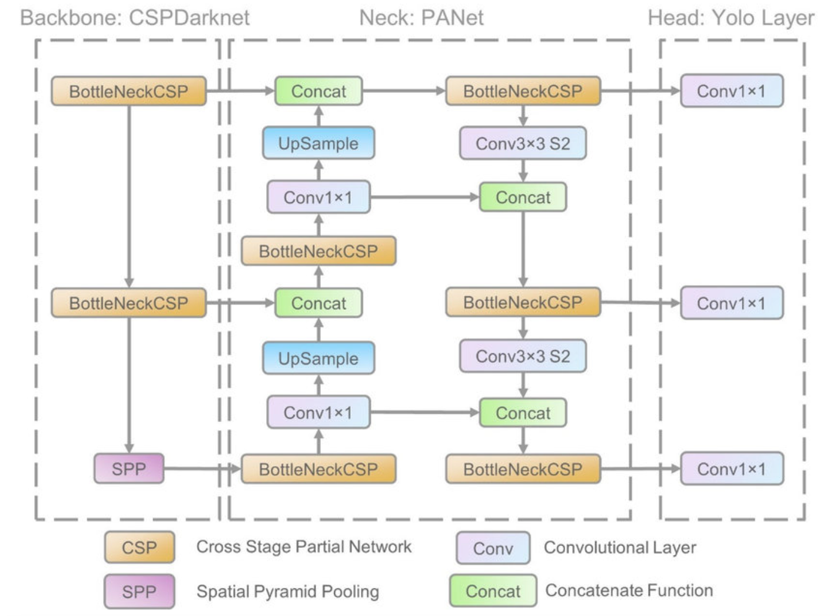

On the other hand, the YOLOv5 model was trained for 100 epochs by running the train.py script with the appropriate parameters such as the batch size, model name, and number of epochs.

Modern deep learning models, such as the YOLOv5 model, have demonstrated exceptional performance in object detection tasks, including licence plate recognition. In contrast to conventional two-stage object detection models, the model employs a single-stage object detection architecture, allowing for quicker and more effective processing.

The YOLOv5 model can precisely detect and extract licence plate regions from photos in the context of licence plate recognition. The model is precisely trained to locate the licence plate's precise location in an image using a dataset of photos and the accompanying bounding box values kept in an XML file.

The YOLOv5 model extracts features from the input image using a convolutional neural network (CNN) backbone with many convolutional layers. The bounding box coordinates and the class probabilities for each detected object, including number plates, are then produced using these characteristics after being processed by a number of fully connected layers.

The speed and effectiveness of the YOLOv5 model for licence plate recognition is one of its key benefits. Even with outdated hardware, real-time licence plate detection and recognition is possible because to the model's optimisation for use with contemporary GPUs. The YOLOv5 model is a flexible solution for licence plate recognition in many settings because it can also manage varied lighting conditions, occlusion, and licence plate orientation.

This research is significant as it presents an approach for accurately detecting and identifying license plates, which has applications in various fields such as law enforcement, traffic management, and parking management. The comparison of the two distinct models highlights the importance of selecting the best model for the specific use case, as both models have their strengths and weaknesses.

Overall, the proposed work provides an approach to license plate recognition that may lead to improved accuracy and efficiency, ultimately contributing to the advancement of the field.

**4. PERFORMANCE ANALYSIS**

Object detection techniques are used by licence plate recognition (LPR) models to find and locate licence plates in photos. These models' accuracy significantly depends on their capacity to locate and correctly identify the licence plate in the image, which is accomplished by making use of bounding box parameters like xmin, xmax, ymin, and ymax.

These parameters are crucial because they can give the model accurate localization data, enhancing the model's ability to recognise licence plates accurately and lowering false positives. The model is better able to recognise the characters on the licence plate and tell them apart from other items in the image that may look similar when the licence plate is correctly localised.

In summary, the use of xmin, xmax, ymin, and ymax parameters is crucial for achieving high accuracy and reliability in license plate recognition models. By enabling precise localization of license plates in different scenarios, these parameters play a vital role in improving the performance of LPR models.

**INCEPTION-RESNETV2**

**Loss value at the end of training**

loss: 8.5127e-05

val_loss: 0.0111

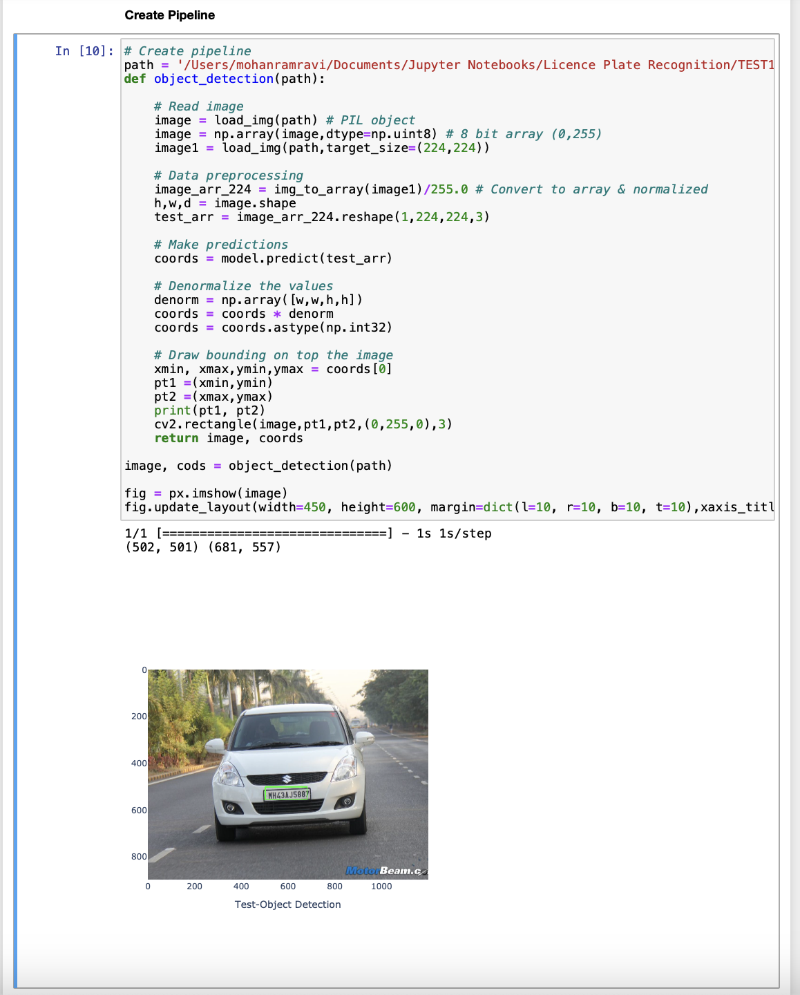

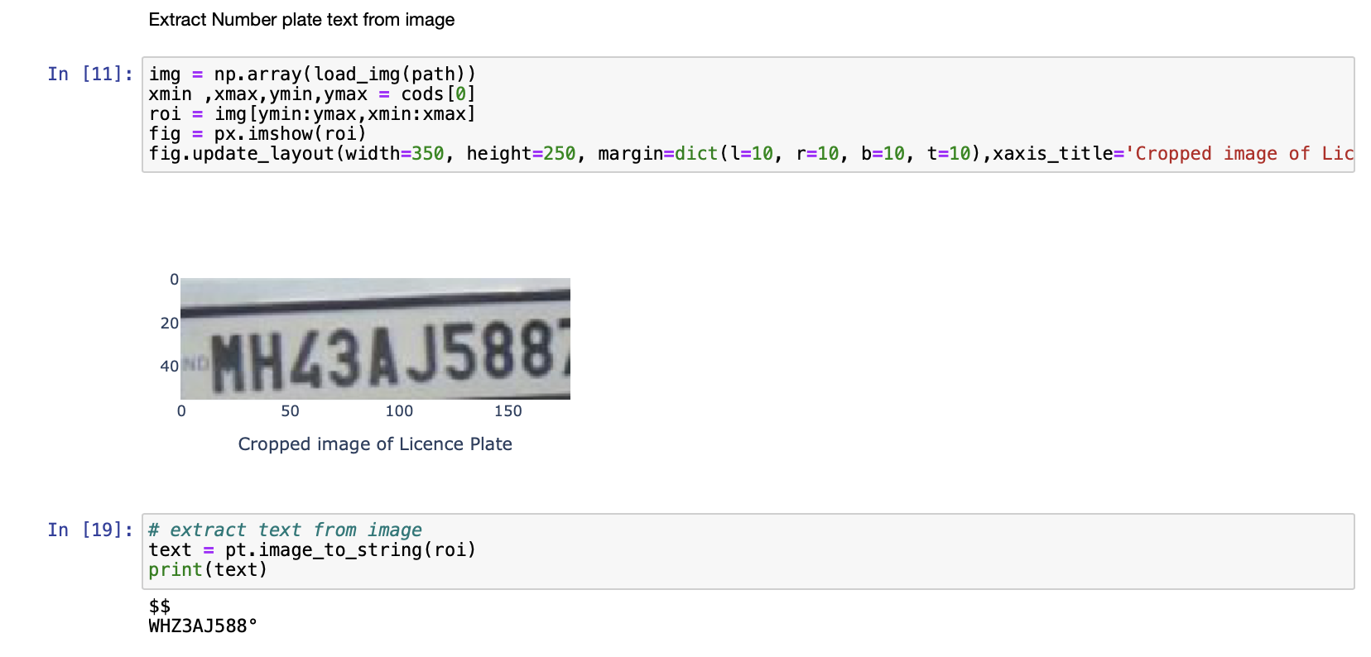

**YOLOv5**

Precision - 0.97837

loss: 0.0054583

|  |  |  |  |  |
| --- | --- | --- | --- | --- |
| **Recall** | **mAP_0.5** | **mAP_0.5:0.95** | **Precision** | **box_loss** |
| **0.99768** | **0.995** | **0.821** | 0.97837 | **0.015116** |

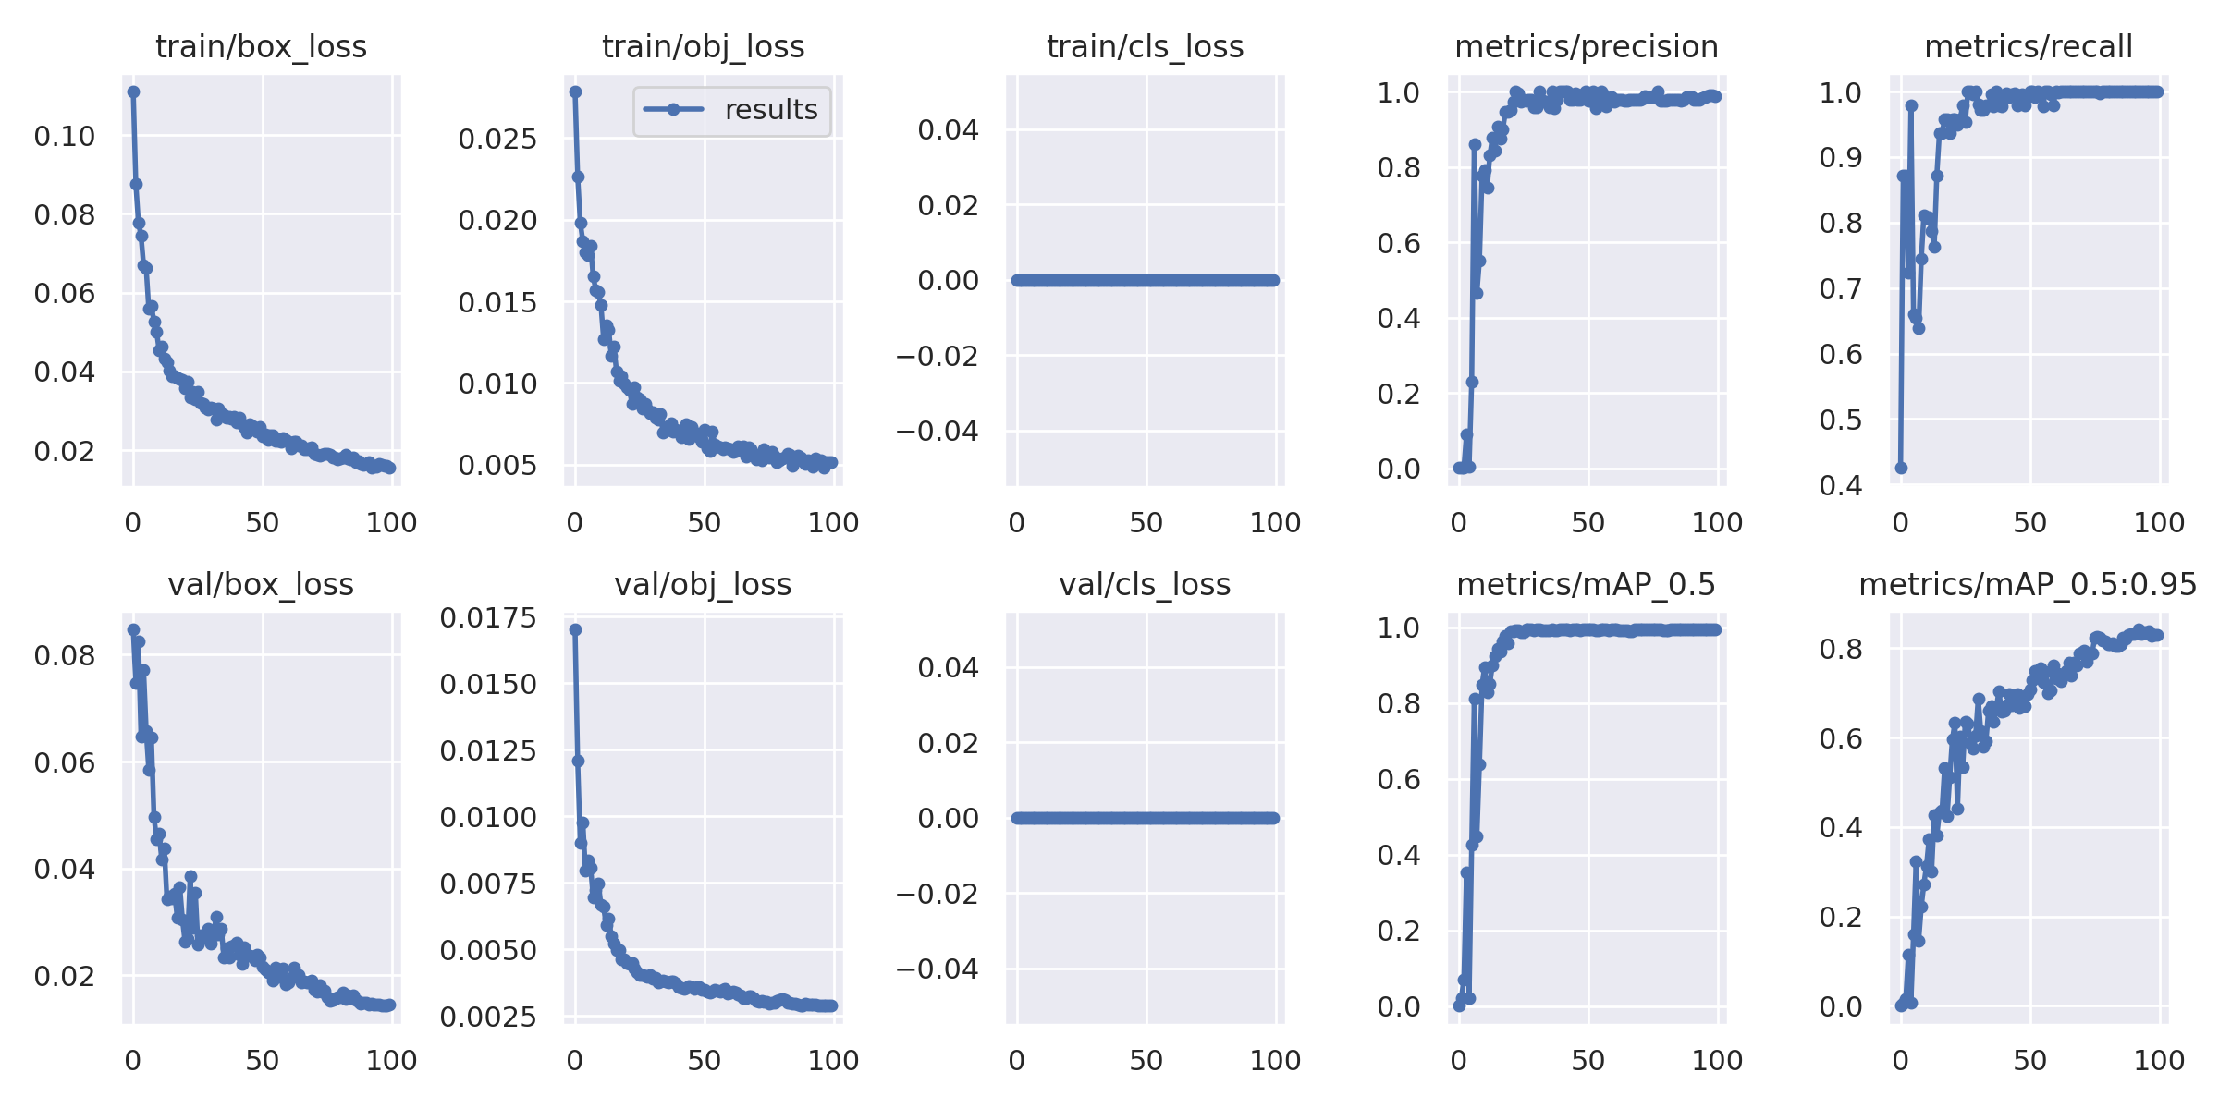

Sample test data validated batches

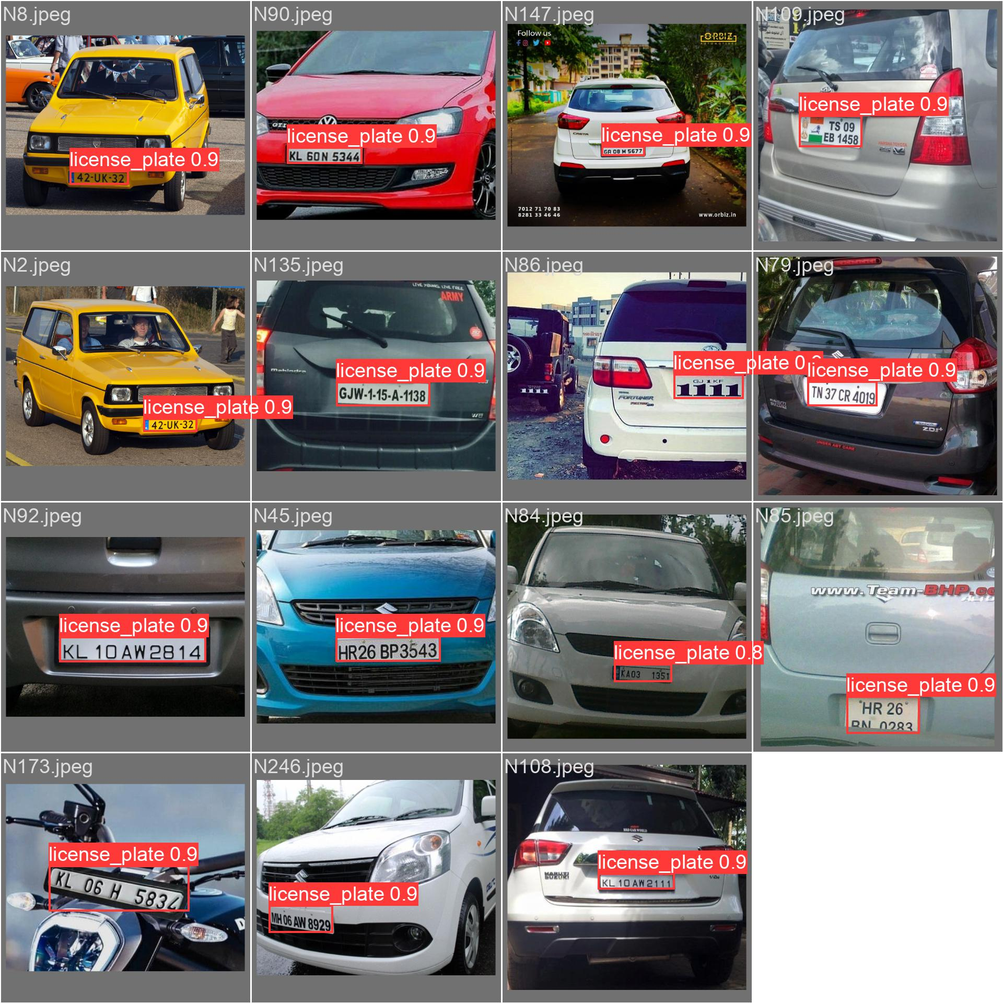

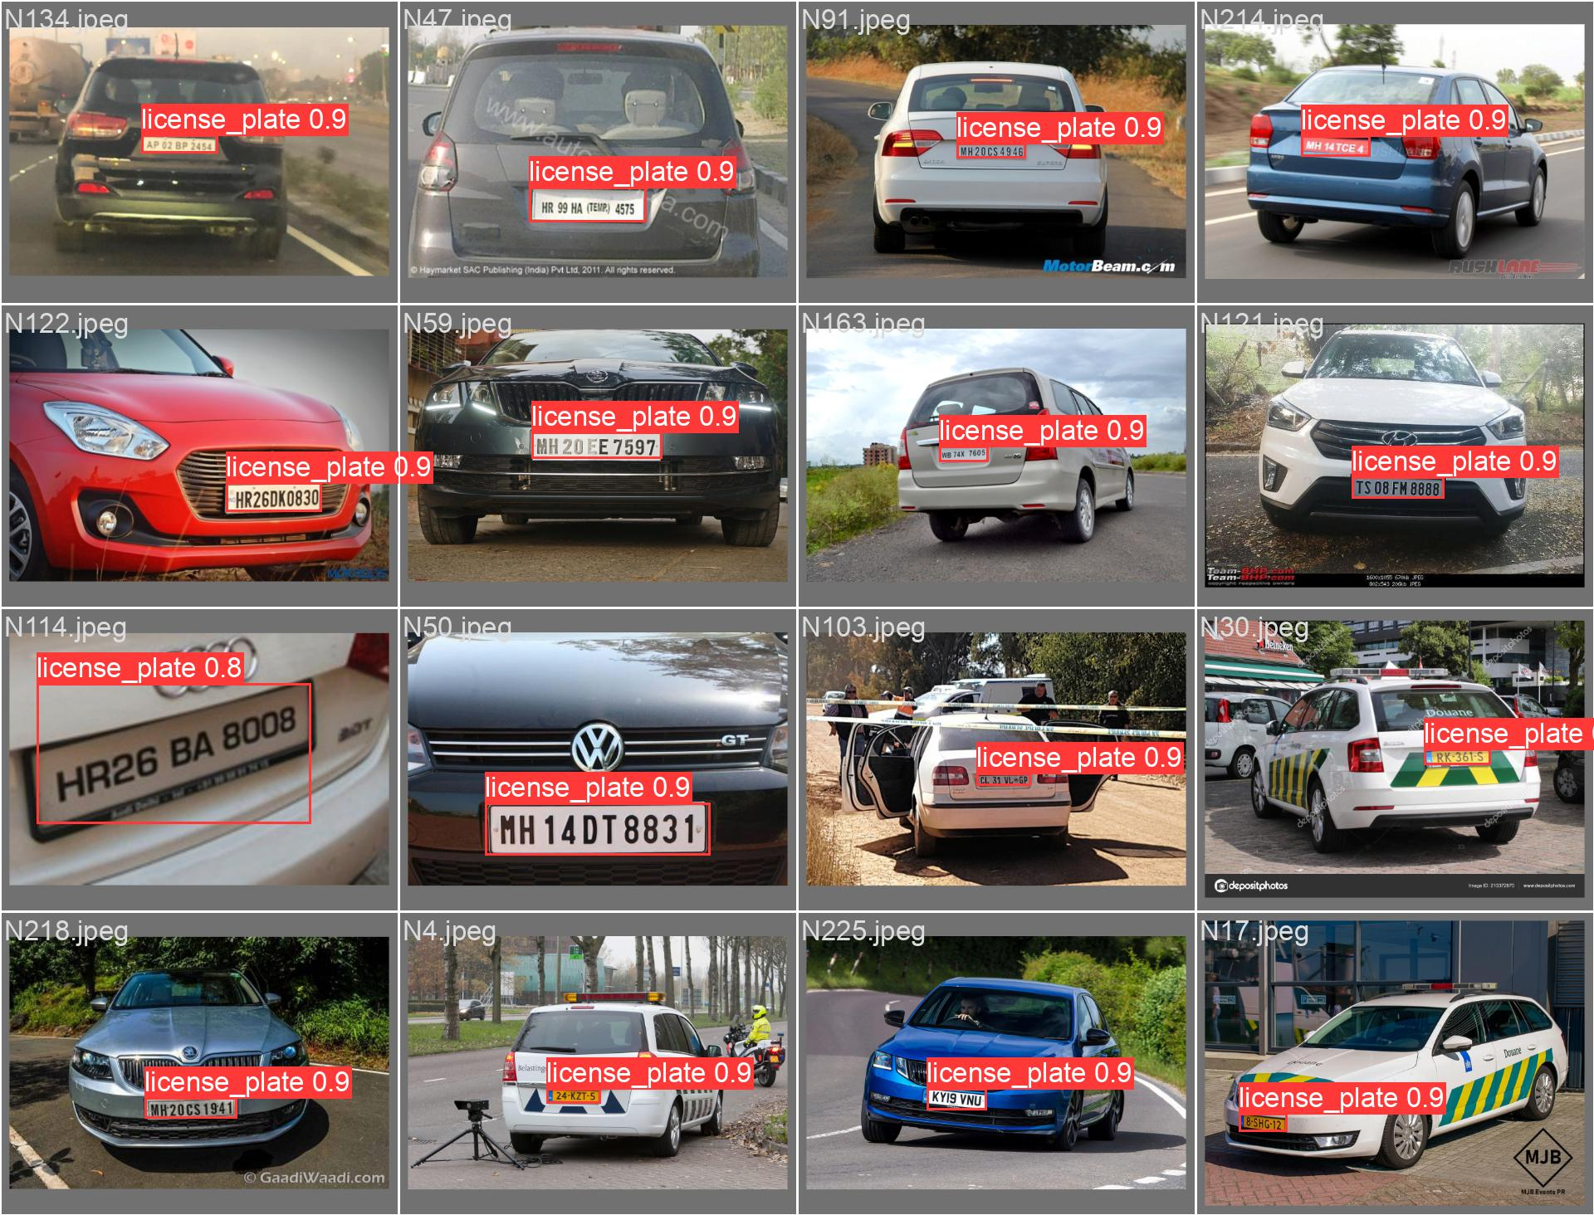

Application tested using random car images

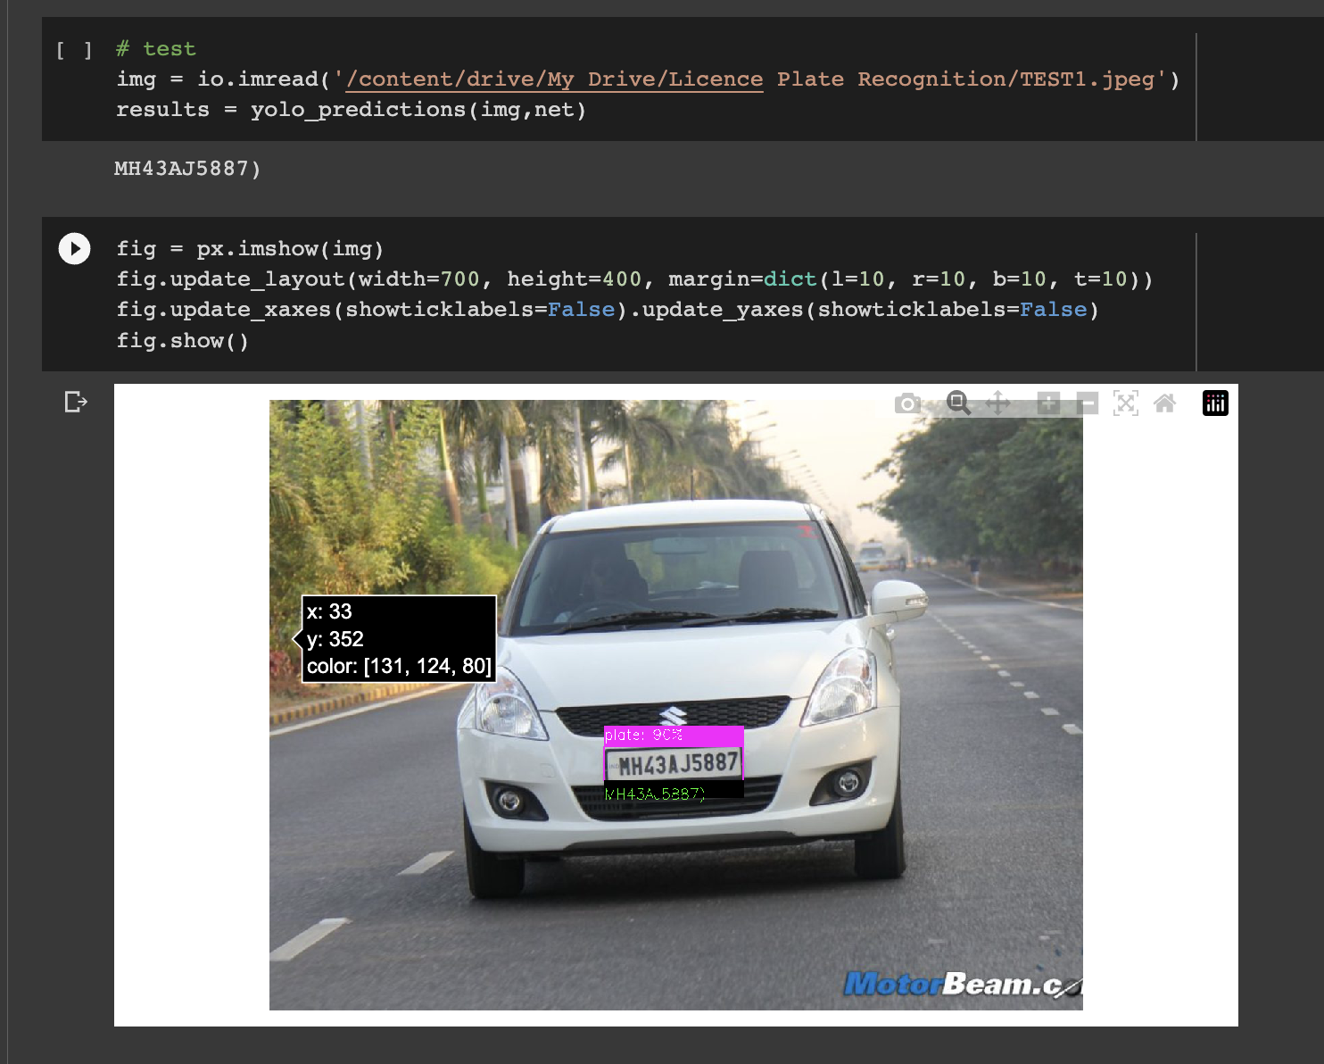

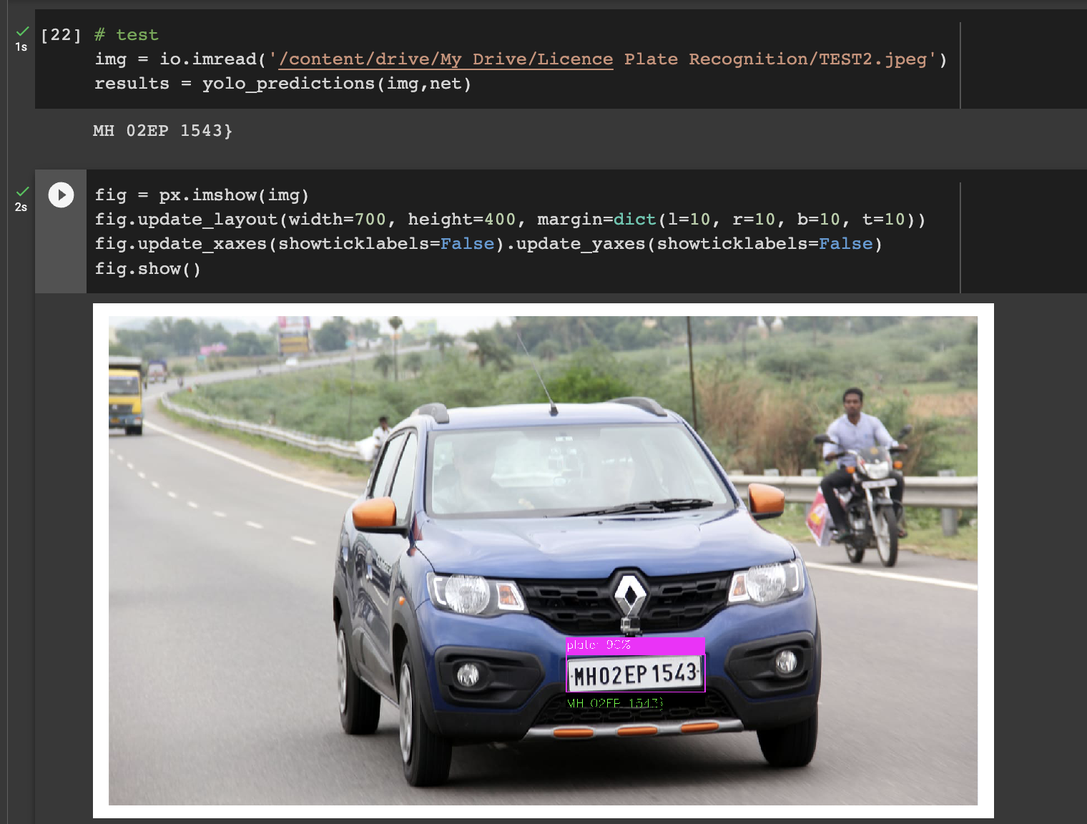

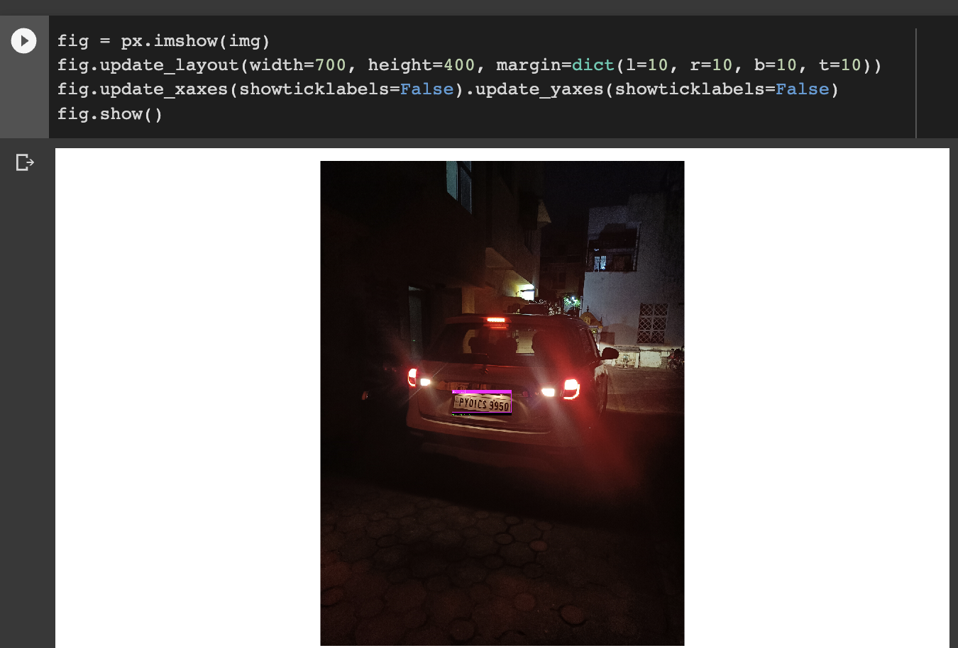

Application tested using random bike image outside of the dataset used in the model

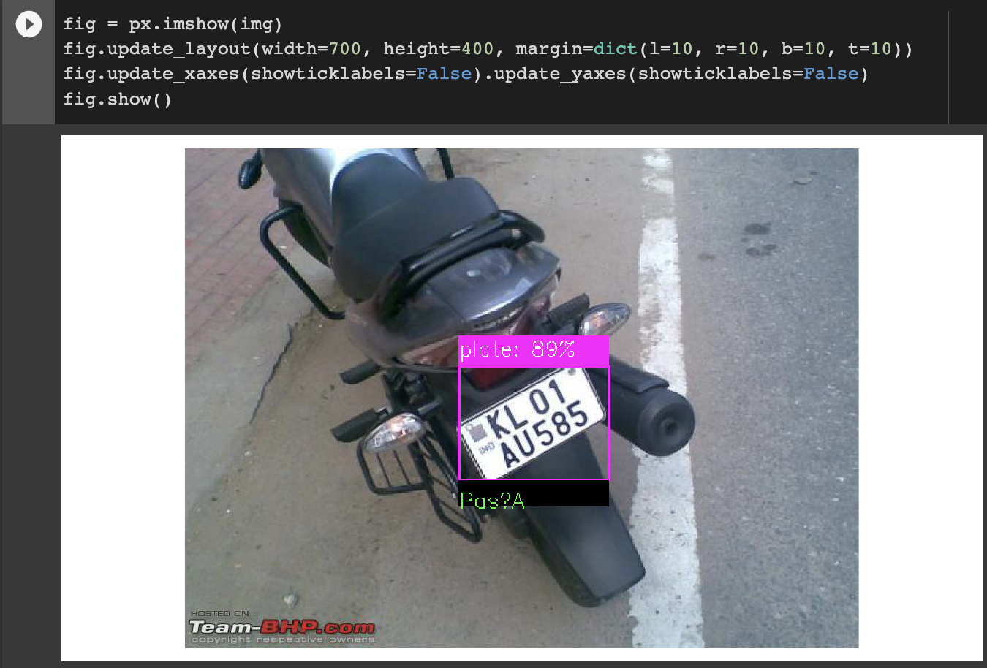

Application tested using toll gate video feed

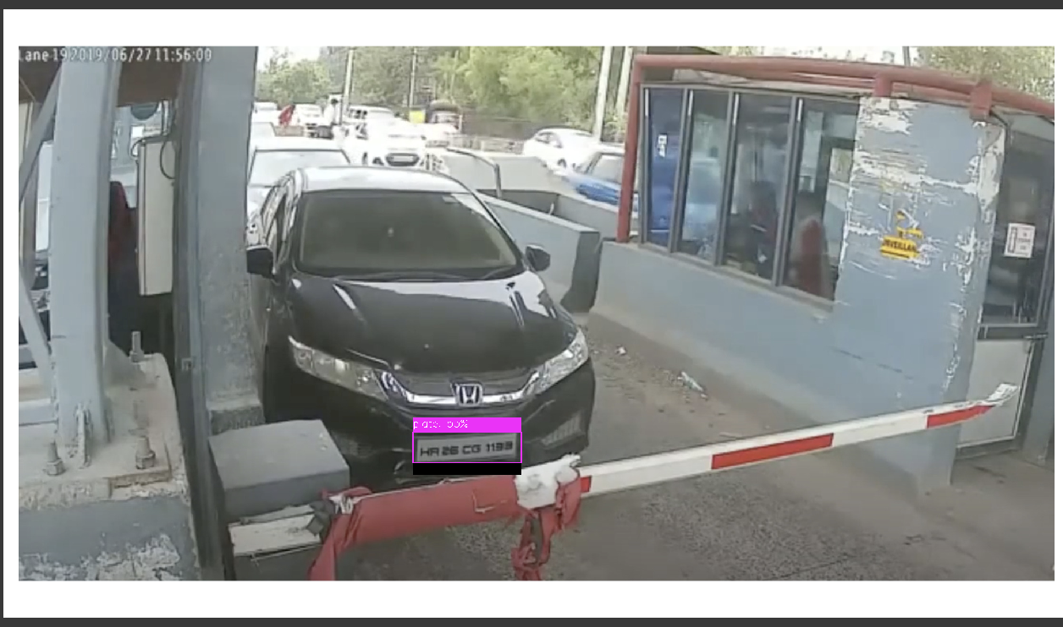

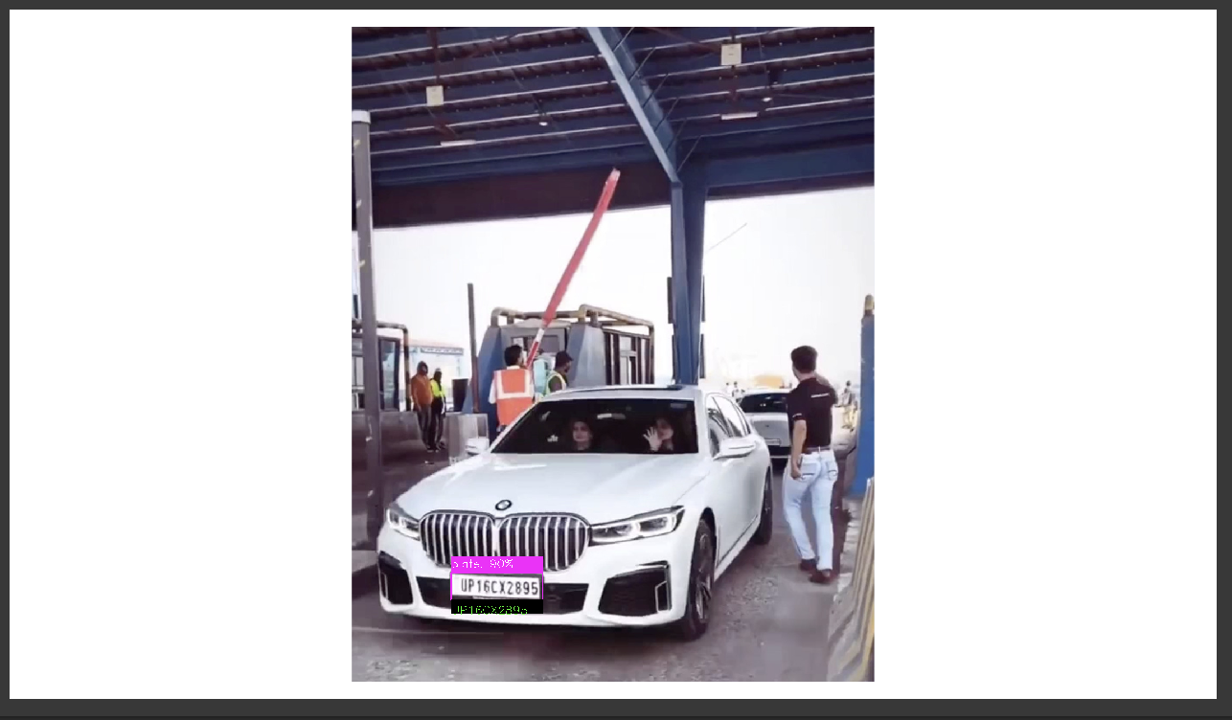

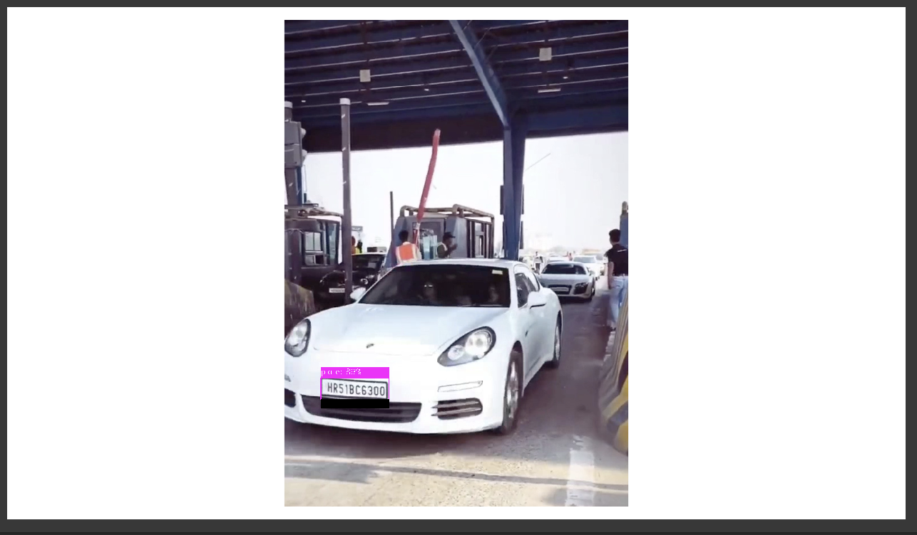

**5. Conclusion**

License plate recognition, which can identify licence plates from digital pictures or video footage, is a crucial technique used in traffic management, parking management and law enforcement. In this work, we suggested the use of real-time licence plate recognition models Inception ResNetV2 and YOLOv5, which can precisely identify and recognise licence plates. According to our research, the YOLOv5 model fared better than the Inception ResNetV2 model in terms of accuracy and precision. These initiatives are essential for enhancing the efficiency and dependability of systems that read licence plates, with potential advantages across a range of industries.

**6. References**

1. Zhang, Z., Xu, H., & Xu, Z. (2019). License plate recognition using CNN with a sub-net for character segmentation. Pattern Recognition Letters, 119, 63-70.
2. Bhagat, N., Nigam, A., & Kumar, V. (2019). Automatic license plate recognition system using improved hybrid feature selection and a novel machine learning algorithm. Expert Systems with Applications, 124, 31-42.
3. Zhao, W., Chen, Y., & Chen, Z. (2019). License plate recognition based on deep learning and multiple-feature fusion. IEEE Transactions on Intelligent Transportation Systems, 20(3), 1013-1023.
4. Fakhrizadeh, M., & Tavakoli, M. (2019). A hybrid method for license plate recognition using morphology and deep learning. Multimedia Tools and Applications, 78(17), 24617-24638.
5. Yang, Q., Jin, L., & Shi, Y. (2019). Robust license plate detection and recognition using deep learning and genetic algorithm optimization. Neural Computing and Applications, 31(8), 3791-3803.
6. Zhang, H., Xu, S., Wang, J., & Yang, H. (2017). A new method for license plate recognition based on deep belief network. IEEE Transactions on Intelligent Transportation Systems, 18(9), 2354-2363.
7. Tang, Y., Chen, C., & Yang, J. (2018). License plate recognition using convolutional neural networks and unsupervised feature learning. Pattern Recognition, 81, 295-308.
8. Kim, K. H., & Lee, S. W. (2017). Recognition of vehicle license plate considering affine deformation. Multimedia Tools and Applications, 76(22), 23087-23106.
9. Soleymani, S., Sohail, A., & Aggarwal, A. (2017). Real-time license plate recognition using deep convolutional neural network on FPGA. Journal of Real-Time Image Processing, 14(4), 795-804.
10. Su, C., Lu, Z., & Xue, Y. (2017). An automatic license plate recognition system based on deep learning. International Journal of Grid and Distributed Computing, 10(12), 203-214.
11. Kheirandishfard, M., & Jafari, R. (2018). A real-time license plate recognition system using deep convolutional neural networks. Expert Systems with Applications, 107, 96-107.
12. Sengupta, S., Kar, S., & Ghosh, S. (2018). Automatic license plate recognition using convolutional neural network and support vector machine. International Journal of Computer Applications, 179(2), 1-6.
13. Hu, M., Zhang, Y., & Niu, L. (2020). License plate recognition based on segmentation and recognition networks with multi-objective optimization. Journal of Ambient Intelligence and Humanized Computing, 11(6), 2383-2394.
14. Zhang, L., Jiang, B., & Tang, J. (2019). A license plate recognition algorithm based on deep learning and spatial pyramid pooling. Multimedia Tools and Applications, 78(14), 20031-20049.